Lab Program Number: 1 Date: 2082-03-01

Title: Understanding of Basic Network Equipment

**THEORY:**

**Network equipment**

Network equipment refers to the physical devices used to connect, manage, secure, and control data traffic between computers and other digital devices on a network. These devices ensure smooth communication within local networks (LANs) or between networks (like the internet). Examples include Router, Switch, Modem, Hub, Bridge, Repeater, Firewall, Network Interface Card (NIC), etc.

1. **Repeater:**

A **repeater** is a network device that helps extend the distance a signal can travel without getting weak. When data moves through cables or air over long distances, the signal can lose strength (called attenuation).

**Function:**

A repeater strengthens weak network signals and sends them forward to cover longer distances. It helps extend network range and keeps the connection strong, without changing or filtering the data.

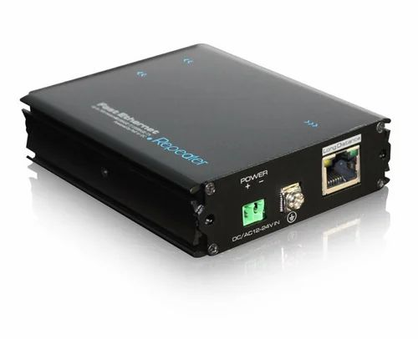

Fig: Repeater

1. **Hub:**

A hub is a basic network device that connects multiple computers or devices in a local area network (LAN). It works at the Physical Layer (Layer 1) of the OSI model and simply transmits data to all connected devices.

**Function:**

A hub receives data from one device and sends (or "broadcasts") it to all other connected devices, whether they need it or not. It helps in creating a simple network but does not filter or direct traffic, which can cause unnecessary data flow and collisions.

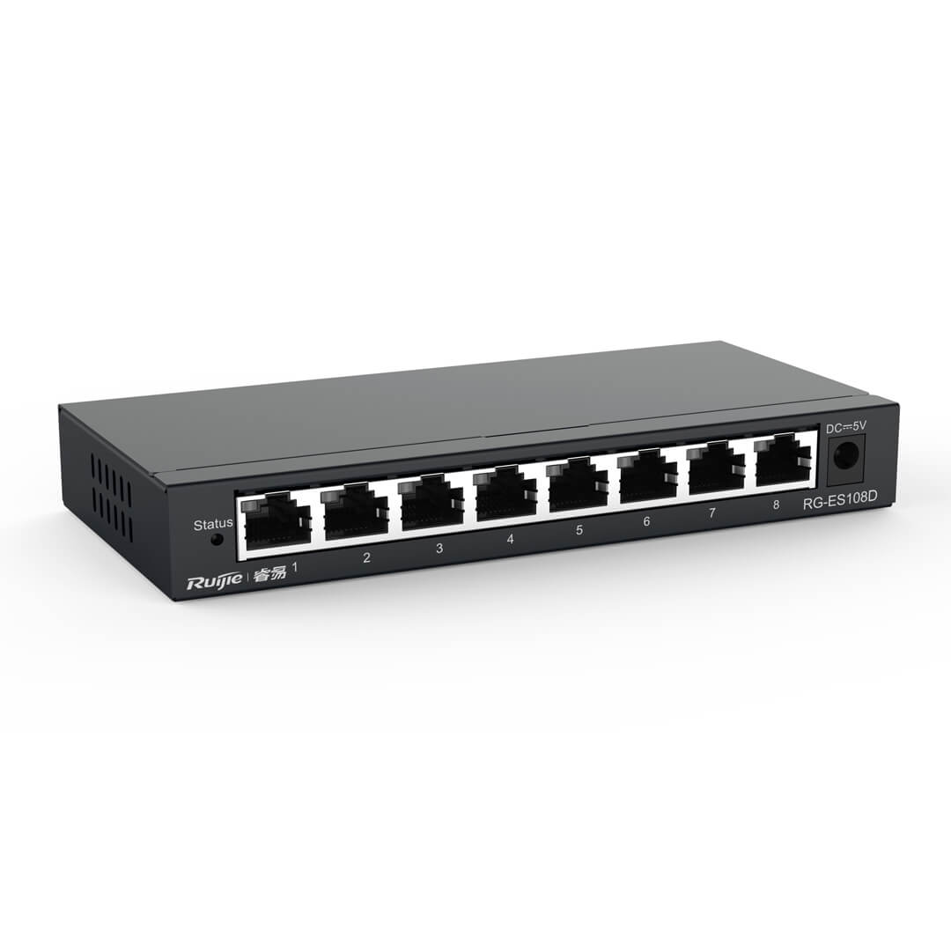

Fig: Hub

1. **Switch:**

A switch is a network device that connects multiple devices within a local area network (LAN) and directs data only to the specific device it is meant for. It operates at the Data Link Layer (Layer 2) of the OSI model (some also work at Layer 3).

**Function:**

A switch receives data from one device and sends it only to the device it is intended for. This reduces unnecessary traffic, improves network speed, and prevents collisions, making it smarter and more efficient than a hub.

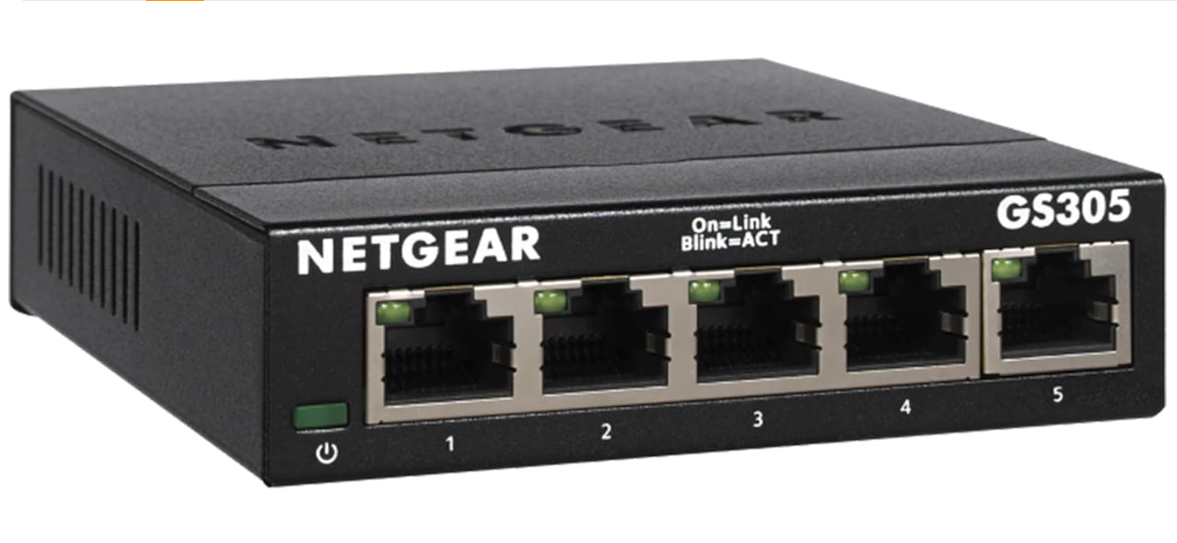

Fig: Switch

1. **Bridge:**

A bridge is a network device that connects two or more separate LAN segments and helps them function as a single network. It works at the Data Link Layer (Layer 2) of the OSI model and uses MAC addresses to decide where to forward data.

**Function:**

A bridge connects two parts of a network and helps control traffic between them. This helps reduce unnecessary traffic, avoids data collisions, and improves overall network performance.

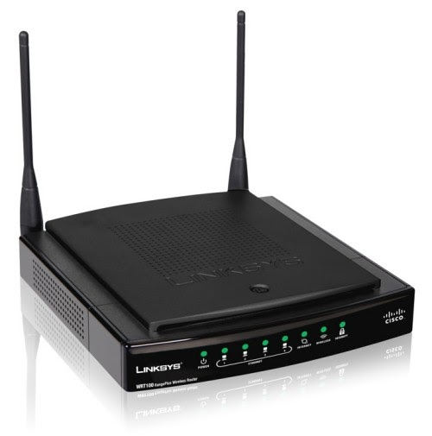

Fig: Bridge

1. **Router:**

A router is a network device that connects multiple networks together and directs data between them. It works at the Network Layer (Layer 3) of the OSI model and uses IP addresses to determine the best path for sending data to its destination.

**Function:**

A router receives data packets from one network and decides the best route to send them to another network. It reads the IP address of each packet and forwards it to the correct next network or device.

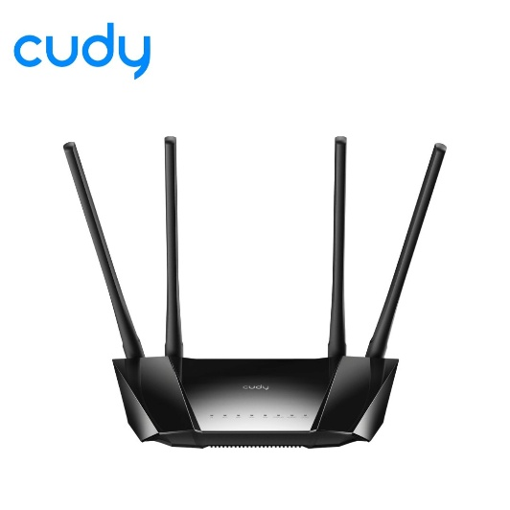

Fig: Router

1. **Modems:**

A modem (modulator-demodulator) is a device that connects your home or office network to the internet. It converts digital signals from your computer into analog signals for transmission over telephone or cable lines, and vice versa.

**Function:**

It changes digital data into a form that can travel over internet lines and then back into digital so your devices can use it allowing internet access.

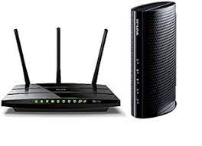

Fig: Modem

1. **Firewall:**

A firewall is a network security system—either in the form of hardware, software, or a combination of both—that is designed to monitor, filter, and control incoming and outgoing network traffic based on a set of predefined security rules.

**Function:**

Firewall, protect a computer or network from unauthorized access. It acts like a barrier between a trusted internal network and untrusted external sources (like the internet).

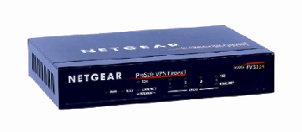

Fig: Firewall

1. **Wireless Access Point (WAP):**

**A Wireless Access Point (WAP)** is a **networking device** that allows **wireless devices** (like smartphones, laptops, tablets) to **connect to a wired network** using **Wi-Fi** or other wireless standards. It acts as a **bridge** between the wired network (like your router or switch) and wireless devices.

**Function:**

A Wireless Access Point sends and receives signals, giving internet access to smartphones, laptops, and other wireless devices.

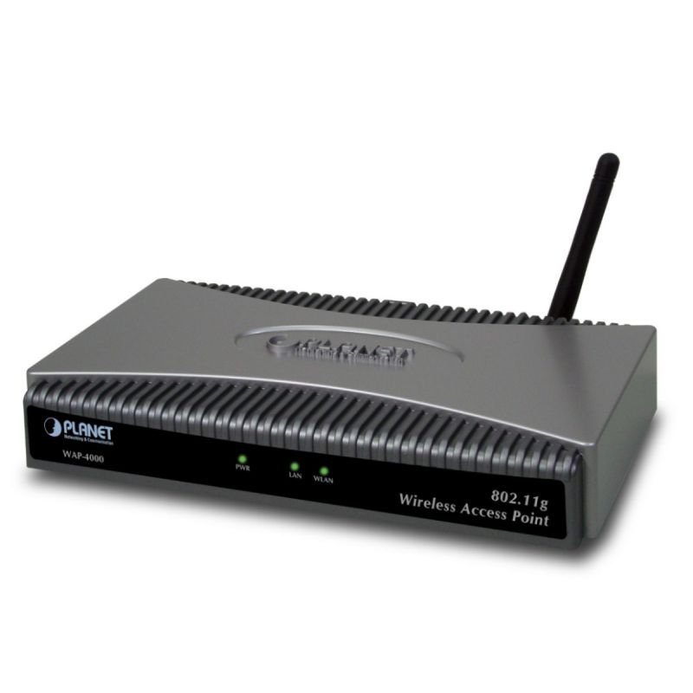

Fig: WAP

1. **Network Interface card:**

A Network Interface Card (NIC) is a hardware component that allows a computer or device to connect to a network. It can be built-in (integrated) or installed separately as an expansion card.

**Function:**

NIC is used to convert data from the computer into signals that can be transmitted over a network and vice versa.

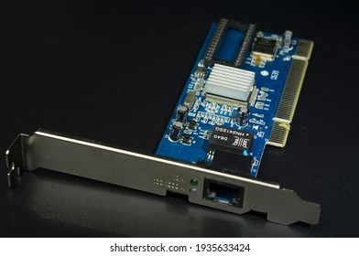

Fig: Network Interface card

1. **VOIP Endpoint:**

A VoIP (Voice over Internet Protocol) endpoint is a device or software that enables a user to make voice or video calls over the internet instead of traditional phone lines.

**Function:**

A VoIP endpoint sends and receives voice data over a network, allowing people to talk in real time using the internet.

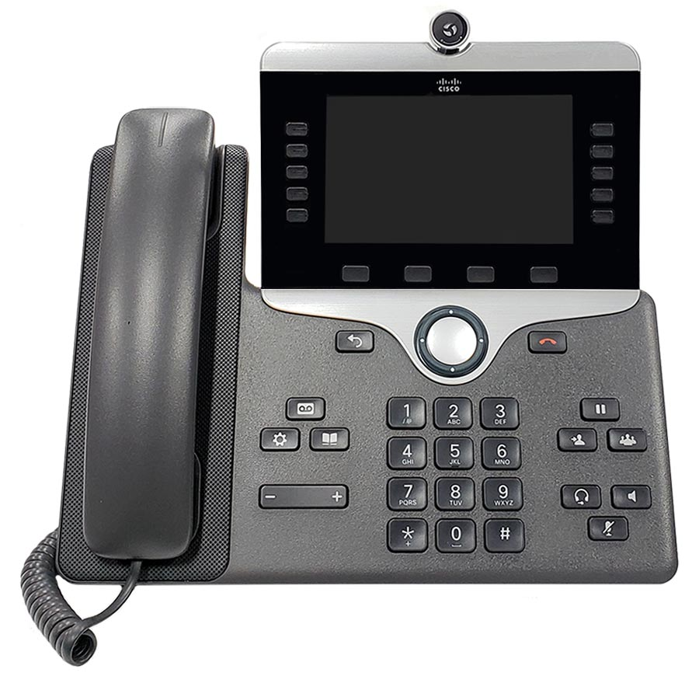

Fig: VOIP endpoint

**Conclusion:**

In this practical, we studied different types of network devices such as repeaters, hubs, switches, bridges, routers, modems, firewalls, NICs, wireless access points, and VoIP endpoints. We understood their individual functions and how they contribute to building a network. This activity helped us learn how these devices work together to enable communication, manage traffic, and keep networks secure. The knowledge gained from this practical is useful for setting up and maintaining efficient computer networks.

Lab Program Number: 2 Date: 2082-03-01

Title: Understanding of Ethernet Wiring in detail

**THEORY:**

**Equipment used in LAN Cabling**

1. **Ethernet Cable**

An Ethernet cable is the physical medium that carries data signals between devices in a local area network. Inside, it contains eight small copper wires twisted into four pairs, each pair color-coded to reduce interference. Different categories (like Cat5e, Cat6) offer varying speeds and shielding suitable for home or commercial networks.

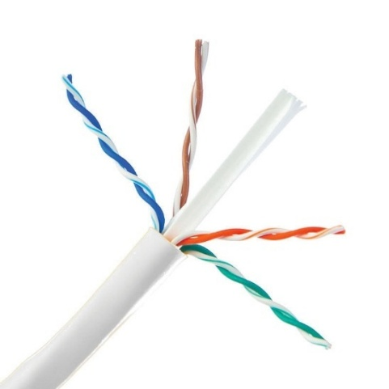

Fig: Ethernet Cable

1. **RJ45 Connectors**

RJ45 connectors are plastic plugs attached to the ends of Ethernet cables. They have eight metal pins that connect to the eight wires inside the cable, allowing it to plug securely into network ports on devices like computers, switches, or routers.

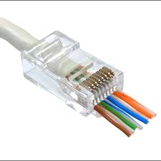

Fig: RJ45 Connector

1. **Cable Stripper**

A cable stripper is a tool used to remove the outer plastic jacket of the Ethernet cable. It exposes the internal twisted wires without damaging them, making it easier to arrange the wires properly before attaching the connector.

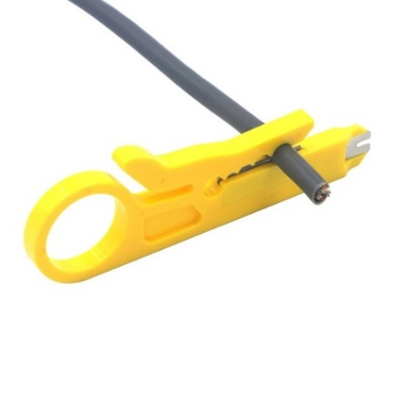

Fig: Cable stripper

1. **Wire Crimper (Crimping Tool)**

The crimping tool is used to attach the RJ45 connector to the Ethernet cable. It presses the metal pins inside the connector firmly into the cable’s wires, securing a strong physical and electrical connection.



Fig: Wire Cripper

1. **Cable Tester**

A cable tester checks if an Ethernet cable is wired and working correctly by sending signals to detect faults like open circuits, short circuits, or crossed wires.

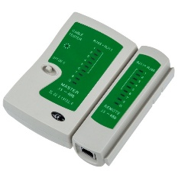

Fig: Cable Tester

**WIRING DETAILS**

1. **Straight-Through:**A straight-through cable is a type of Ethernet cable in which the internal conductors are arranged in the same sequential order at both ends. It is commonly used to connect unlike network devices, such as a computer to a switch or a router to a hub. Each end of the cable is terminated with an 8P8C (8-position, 8-contact) modular connector, and the wire positions are identical on both sides. In other words, pin 1 on one connector is directly connected to pin 1 on the other, pin 2 to pin 2, and so forth through pin 8, ensuring proper alignment and signal transmission.The wire color order in TIA/EIA-568A is:

|  |  |
| --- | --- |
| **Pin** | **Cable Color (TIA/EIA 568A)** |
| Pin 1 | White-Green |
| Pin 2 | Green |
| Pin 3 | White Orange |
| Pin 4 | Blue |
| Pin 5 | White-Blue |
| Pin 6 | Orange |
| Pin 7 | White-Orange |
| Pin 8 | Brown |

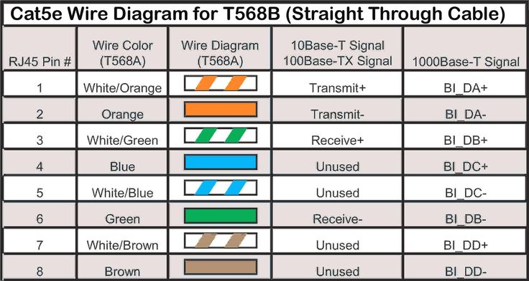

Fig: Straight-Through Cable

1. **Cross Over:**

A crossover cable is a type of Ethernet cable used to connect similar devices directly, such as computer to computer or switch to switch, without needing a hub or switch in between. Unlike a straight-through cable, a crossover cable has its wires swapped at both ends—the transmit (TX) and receive (RX) pairs are crossed. For example, pin 1 is connected to pin 3, and pin 2 to pin 6, allowing the devices to send and receive data correctly. It’s mainly used in older networks, as modern devices often have auto-sensing ports that make crossover cables less necessary. The wire color order in TIA/EIA-568A & TIA/EIA 568B is:

|  |  |  |
| --- | --- | --- |
| **Pin** | **Cable Color (TIA/EIA 568A)** | **Cable Color (TIA/EIA 568B)** |
| Pin 1 | White–Green | White-Orange |
| Pin 2 | Green | Orange |
| Pin 3 | White–Orange | White–Green |
| Pin 4 | Blue | Blue |
| Pin 5 | White-Blue | White-Blue |
| Pin 6 | Orange | Green |
| Pin 7 | White-Orange | White-Brown |
| Pin 8 | Brown | Brown |

Fig: Crossover Cable

**Steps Required to Construct**

**Straight Through**

1. Remove the covering of CAT 5 cable. Strips off about 1 inches of the plastic jacket off the end of the cable using cable stripper.
2. Cut the thread.
3. Untwist the 4 wire pairs and straighten the eight wires of the cable.
4. Arrange the wire in order 1, 2, 3, 4, 5, 6, 7 & 8 follow the colour code standard straight- through cable.
5. Using Crimping tool's cutter cut the end of wires so that they are of same length.
6. Insert the arranged cable in the RJ45 connector.
7. In crimping tool insert the head of RJ45 connector and crimp (press) it hardly.
8. Repeat Steps 1 through 7 to terminate the other end of the cable. Use the same scheme to finish the straight-through cable.
9. Test a straight cable by using cable tester.

**Cross Over:**

1. Remove the covering of CAT 5 cable. Strips off about 1 inches of the plastic jacket off the end of the cable using cable stripper.
2. Cut the thread.
3. Untwist the 4 wire pairs and straighten the eight wires of the cable.
4. Arrange the wire in order 1, 2, 3, 4, 5, 6, 7 & 8 by following the color code standard of Cross Over cabling.
5. Using Crimping tool's cutter cut the end of wires so that they are of same length.
6. Insert the arranged cable in the RJ45 connector.
7. In crimping tool insert the head of RJ45 connector and crimp (press) it hardly.
8. Repeat Steps 1 through 7 to terminate the other end of the cable. Use the same scheme to finish the Cross Over cable.
9. Test a cross over cable by using cable tester.

**Conclusion**

In this practical, we learned how to make and test Ethernet cables using straight-through and crossover methods. We used tools like crimpers, RJ45 connectors, and cable testers, and followed color coding standards. This activity helped us understand the basics of network cabling and improved our practical networking skills.